Subject Case Pronouns
Since every sentence must have a subject, the first type of Spanish pronoun you learn to use is the subject pronoun. These little words are used to replace a noun that serves as the subject of the sentence.
English subject case pronouns
The subject case pronouns listed in Table 1 are only used to replace a noun if the noun is serving as the subject of the sentence.
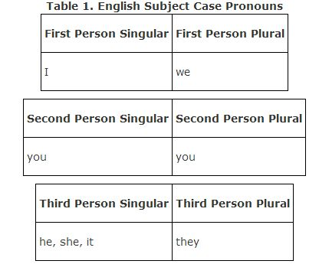
Pronouns in the top row (I, we) are called first person pronouns. On the left is the singular first person, I, and on the right is the plural first person, we. If you think about it, when I have a group with me, the plural of I is we.
Pronouns in the second row down are second person pronouns (you, you). In English, the second person singular is the same as the second person plural, so the pronoun you is written twice. On the left, you refers to one person, and the you on the right refers to more than one person, like “you guys” or “y'all.”
Pronouns in the third row are third person pronouns. The singular third person pronouns have one for each gender, he and she. For genderless objects, the pronoun it is used. The plural of the third person does not specify gender in English, so the generic pronoun they is used when talking about any group of people or things. The singular third person pronouns in English are different depending on the gender of the person being replaced (he and she). However, the plural version of these pronouns is the same regardless of gender (they, they).
Because objects do not have gender in English, the pronoun it is used to represent a thing or object that is the subject of the sentence. There is no Spanish equivalent to the subject pronoun it because all nouns are either masculine or feminine. If you want to say something like “it's important” or “it's raining” you simply use the él form of the verb with no pronoun.

Spanish subject case pronouns

The English pronouns do not exactly match up with Spanish pronouns so Table 2 presents the pronouns in a different way. The best way to learn these pronouns is to make flashcards with the English on one side and the Spanish on the other. Be sure to specify things like feminine and formal or informal.
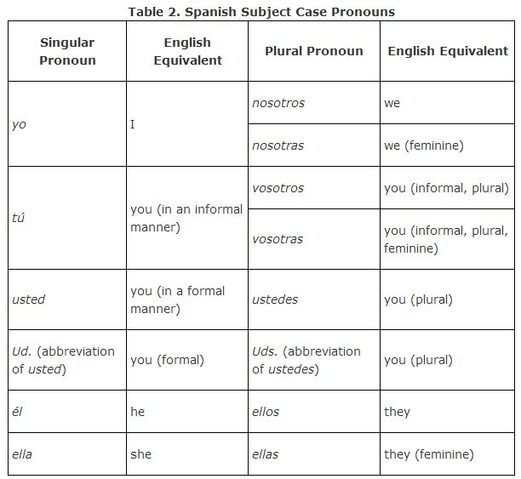

Subject pronouns in Spanish are usually not capitalized except when used as the first word of a sentence. Notice, however, that the abbreviated forms Ud. and Uds. are always capitalized, and the longer versions ustedand ustedes are not capitalized except when serving as the first word in a sentence.
You probably don't think about the fact that the English pronoun I is always capitalized. The Spanish equivalent, yo, is not capitalized, unless it is the first word of the sentence.
Table 3 lists the pronouns in a specific order to help you conjugate verbs. This organizational chart is called a conjugation chart. You should memorize the order and grouping of the pronouns listed. Notice that nosotros/nosotras is across from yo; vosotros/ vosotras is across from tú; él is across from ellos; ella is across from ellas; and usted is across from ustedes. It is important to maintain this form when you write the pronouns in a conjugation chart. Also remember that usted/Ud. and ustedes/Uds. are second person pronouns in English but take the third person form of the verb in Spanish.
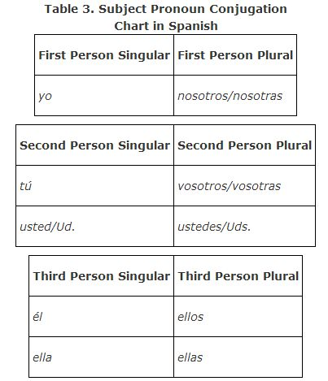
In Spanish, third person pronouns match the gender of the person they represent. The pronoun él means he and ella means she. When you pluralize the third person pronouns, ellos means they and is used to replace an all‐male group or a group of mixed gender. When it is certain that they are all feminine, the pronoun ellas is used.

Differences between English and Spanish subject case pronouns
To use pronouns correctly, it's helpful to have a basic understanding of the differences between English and Spanish subject case pronouns. Some of the pronouns are easy to translate.
The first person singular pronoun I in English is used exactly like the Spanish word yo, except that yo is always lowercase unless it starts a sentence. However, the corresponding first person plural pronoun we doesn't indicate gender in English. The Spanish first person plural pronoun nosotros is typically used to express we unless there is absolute certainty that the group of people that we represents is 100 percent female. Nosotras is the feminine version of nosotros and is used when we are all girls. It is tempting to abbreviate nosotros or nosotras, but you should not do so. The word nos is a very different word and will cause you much confusion later if you use it as an abbreviation.
In Spanish, if someone stands in front of a group and says, “You're invited to my party,” the pronoun they use will give away whether they are speaking to one person or the entire group. Also, Spanish has a special pronoun to address someone in a formal or less formal manner.
The second person pronoun in English is you. This is an extremely vague pronoun because it can refer to either one person or a group, as in “you guys” or “y'all.” The Spanish have a singular version of you and a plural version of you. The second person singular pronoun usted is formal and often abbreviated Ud. The second person plural version of you is ustedes (abbreviated as Uds.).
The pronoun tú is the informal way to say you. This is used when you talk to someone younger than you or someone who is a close friend or family member. It is safest to use the usted way of saying you unless you are certain that you won't be insulting someone by using the informal tú pronoun. The plural form of tú is vosotros, but it is rarely used outside of Spain. Most people don't bother to learn the vosotros pronoun becauseustedes can be used as the plural form of you for any situation. Since Spanish is new to you, it's easier to use ustedes any time you want to address a group as “you guys” or “y'all.”

Replacing nouns with subject case pronouns
Remember that a subject pronoun is used to replace a noun that is the subject of the sentence. If the subject is a single person, use él or ella to replace the person's name, depending on the gender of the person. If the subject is more than one person, use the pronoun ellos unless all of the people included in the subject are female. If the subject is a thing rather than a person, the subject pronoun is often eliminated completely, or the subject pronouns él or ella are used to represent the gender of the noun being replaced.

Choose the appropriate subject pronoun to answer the questions.

What is the pronoun for “he”?
- él
- ella
- lo
What is the subject pronoun for “it”?
- el
- ella
- it doesn't exist
What is the pronoun for “we”?
- vosotros
- ellos
- nosotros

Pronoun Cases
Pronouns come in cases. A case of pronouns is a list of pronouns used to replace a noun that acts as a certain part of speech. If you want to use a pronoun to replace a noun that is the subject of a sentence, you must select the appropriate pronoun from the subject case of pronouns. A noun that is acting as the direct object of the sentence can only be replaced by one of the pronouns from the direct object case.

A noun can play several different roles in the sentence. It can be the subject, direct object, indirect object, object of a preposition, or something with a scary name called a predicate nominative. Which pronoun you use to replace a noun depends on what role the noun is playing in the specific sentence you are analyzing.

Choose the appropriate subject pronoun to answer the questions.

Which pronoun would be used to address your friends “Juan y Diego”?
Vosotros
Ustedes
Ellos

Which pronoun would be used to refer to Marcos and his three sisters?
- ellas
- ellos
- nosotros
Which pronoun would be used to refer to “Elena, Marta y Alicia”?
- ellos
- ellas
- nosotras
Which pronoun would be used to refer to yourself and a friend?
- ellos
- ustedes
- nosotros
Which pronoun would you use to answer a question about yourself?
- yo
- tú
- ella
Which pronoun would you use to answer a question that was asked in the “ustedes” form?
- ustedes
- ellos
- nosotros
Which pronoun would you use to answer a question about your friend Ana?
- yo
- ella
ellas

Pronoun Use
Regardless of what type of pronoun you use, it is important to understand that a pronoun not only replaces a noun, but also all of the description words that go with the noun. To avoid the repetition of long and annoying noun clauses, a pronoun eliminates the noun and all the words that modify (describe) it. Obviously, a pronoun should not be used unless it is clear exactly what the pronoun is replacing. For example:

10% OFF

The extremely beautiful mountain was within sight. It was straight ahead.
In the sample sentence, the pronoun “it” replaces the noun “mountain” and also eliminates all of the modifiers that go with “mountain” because you don't say extremely beautiful “it.” At first you will be replacing simple nouns with pronouns, so there won't be any complex or difficult modifiers. Just remember that when a noun has any modifiers, such as adjectives or articles, they will disappear when that noun becomes a pronoun.

Choose the appropriate subject pronoun to answer the questions.

Which pronoun would most likely be used to address your teacher?
- tú
- usted
- ustedes

Which pronoun would most likely be used to address your little sister?
- tú
- usted
- ella

Which pronoun would most likely be used to refer to your little sister?
- tú
- ella
- ellas

Which pronoun would most likely be used to address two elderly people?
- vosotras
- ustedes
- usted
Which pronoun would most likely be used to refer to your friends José and María?
- vosotros
- ellas
- ellos
“Tú y yo” can be replaced with which pronoun?
- nosotros
- ellos
- vosotros

